January 2019
Good and Welfare  In Memorial Retirees:  Jess Wright  Walter Ray  Charlie Ralph  Gene Wilkinson  Joe Abanatha  Shirley Greene  Andy Ling  Wilbur Demerest  Dennis Huffman  Kenneth Scott |  | Stay Informed  Check out our Web site @  USW104.ORG | UNION MEETINGS  3rd Tuesday of every Month  5:05 am  6:05am  7:10am  7:40am  1:15pm  2:15pm  3:15pm  3:40pm
DID YOU KNOW:  Flexible Spending Account Reminder  You can still submit expenses that you incurred in 2018 that have not yet been submitted.  You have until March 31 of the next year to submit claims for eligible expenses incurred through the previous December 31. This January 1 to March 31 period is called the claims run-out period. Your claim must be postmarked by March 31. |  | Local 104 Communicator  Cheryl Dau  Editor  USW Local 104  3966 Red Brush RD  Newburgh IN 47630  Hall Phone 812-853-3156  Hall Fax 812-853-2973  Email:uswa104@evansville.net  Or Cheryldau@hotmail.com  USW Local 104  P.O. Box 247  Newburgh IN 47629-0247  Http://WWW.USW104.ORG | USW Local 104 SOAR  Mtgs.  2nd Thursday each Month  8:00am @ USW Local 104  Union Hall  3966 Redbrush Rd.  Newburgh, IN
Know Your Contract

Art XXXI. Period of Agreement

Except as otherwise provided below, this Agreement shall terminate 60 days after either party shall give written notice of termination to the other party, but in any event shall not terminate earlier than 12:00 noon, or at the end of the shift starting before noon, whichever is later, May 15, 2019.
If either party gives such notice, it may include therein notice of its desire to negotiate with respect to pensions(existing provisions or agreements as to pensions to the contrary notwithstanding), and the parties shall meet within 30 days thereafter to negotiate with respect to such matters. If the parties shall not agree with respect to such matters by the end of 60 days after the giving of such notice, either party may thereafter resort to strike or lockout as the case may be in support of its position in respect to such matters as well as any other matter in dispute, but not earlier than noon May 15, 2019(the existing agreements or provisions with respect to pension to the contrary notwithstanding).

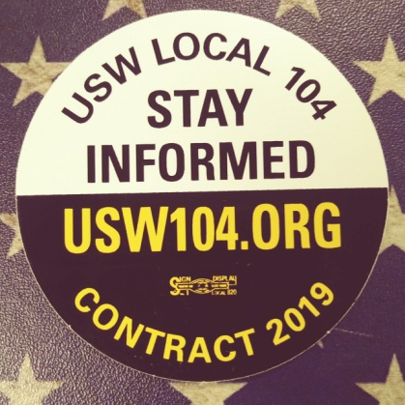

SAVE SOME MONEY EACH PAYCHECK
CONTRACT EXPIRES IN 3 MONTHS

T-shirts are here, see your CAT member to get yours.
Guidelines for the Intent-to-Retire Incentive Program

As an Alcoa employee covered by the Alcoa-USW Master Agreement, you’re eligible to receive a $500. payment (less applicable tax deductions), if you submit your Intent-to-Retire Notice to the Human Resources Department three full months in advance of your retirement date. Please note that employees who receive a voluntary quit package and/or retirement incentive package are not eligible to receive this payment.

If you’ve decided to retire and are choosing a Normal, 62/10, 60/10, 57/35 (under the Level 2/New Hire Plan), or 30-year retirement type, complete and return the attached Intent-to-Retire Notice to the Human Resources Department. To qualify for the $500 payment, follow the guidelines below.

- Complete and return your Intent-to-Retire Notice to the Human Resource Department at least three full months before your selected retirement date, For example, if you want to retire on November 1, 2006, you must submit your notice on or before August 1, 2006. This notice will serve as the written notification of your intention to retire from the company.

- Next, start the formal retirement process, if you’re eligible for one of the retirement types identified above or are within 90 days of becoming eligible to retire under one of the retirement types identified above.

To do so, you can call 1-844-31ALCOA weekdays, from 9 a.m. to 5 p.m. Eastern Standard Time to speak with a retirement specialist who can help guide you through the process. (This process was formerly handled by the Alcoa Retirement Service Center.) Or if you prefer, you can start the process online.
It’s fast and easy.
- Go to Your Benefits Resources Web site at http://resources.hewitt.com/alcoa.
- Select “Pension.”
- Click “Retire Now”
- Follow the steps as instructed.

- Once you’ve started the retirement process, you’ll receive a retirement package in the mail. Carefully follow the instructions, and return all signed forms and required documentations, such as your marriage license together.
If you’ve followed this procedure and retired on your elected date, you’ll receive your $500.00 payment, (less applicable tax deductions), during the first payroll period after your retirement date. Please note that if you submit an Intent–to-Retire Notice to the Human Resources Department and later decide not to retire, you will be disqualified from future participation in this incentive program.

If you have any questions, please contact your Human Resources Department, Alcoa Benefits.
Complete and return your Intent-to-Retire Notice to the Human Resources Department at least three full months before your selected retirement date.

